**Islamabad:**

Taxila Museum

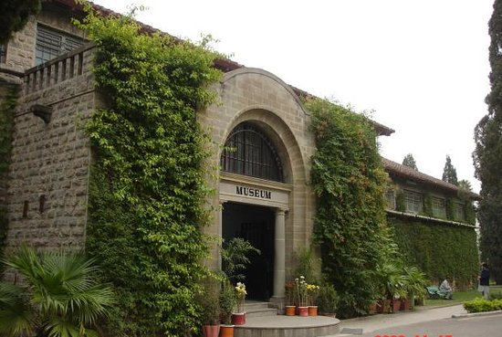

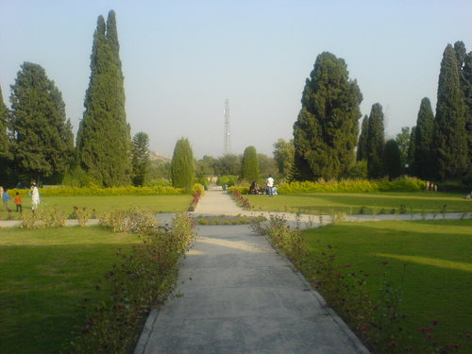

**Taxila Museum** is located at Taxila, Punjab, Pakistan. The museum is home to a significant and comprehensive collection of Gandharan art dating from the 1st to the 7th centuries CE. Most objects in the collection were excavated from the ruins of ancient Taxila.